**Part 10: description of the entity - relationship diagram**

The entity - relationship diagram shown on the next page represents the data structure of the application described so far; the following the glossary of entities si shown:

- USER: the player who use the application, identified by the string "email" (by which he is recognized by the system); he also owns "title" (string) corresponding to the title that you can allocate between various proposed depending on the number of achievements attained. The entity also encompasses the adjacent relationships that bind it to "GAME1", "GAME2", "GAME3" and "GAME4" (identified by a "code" attribute) representing the corresponding sessions of 4 exclusive games for the player in question .

- HERITAGE: is the cultural property, defined by "name" string, and described by the attributes "info" (encyclopedic information), "period" (the historical period in which the structure is part), "typology" (type of structure like church, bridge and so on; information used within the game 2), "coordinates" (geographic coordinates to allow the geolocation), "g1", "g2", "g3", "g4" (boolean elements that show whether the cultural property is active for the corresponding game category).

- CULTURAL ORGANIZATION: entity that manages one or more cultural heritage; identified by "email", it use the authoring tool to manage its properties.

- MATCH1: defines the match of GAME1; when a user chooses the game on the treasure hunt (Portal Treasure) and he chooses from the available cultural property, an instance of "MATCH1" is made, in which are proposed the treasures assigned to that structure. A "TREASURE" is identified by a "code" and it has two other attributes: "info" is a string with the description of the place where the treasure chest is located and "coordinates" are the GPS coordinates that will be used for geolocation and augmented reality; "found" (an attribute of the relationship that binds TREASURE with MATCH1) is instead a boolean attribute indicating whether the chest has already been discovered by the player. The CARD entity represents the 5 cards that are inside of a treasure (defined by a "code" and a "description" parameter).

- GAME2: game session of the "Travel Portal"; it has a relationship with HERITAGE to indicate whether the property is visited by the player that uses of that specific session. It is also linked with entity "MEDAL" with a relationship indicating whether the medal in question has been obtained or not. MEDAL has three attributes: "code" is the string with the identification code, "name" is the name given to the medal and "type" its type ("region", "historical period", "typology").

- GAME3 is the session about the Portal Puzzle and it is linked to PUZZLE through the relationship that has "solved" as attribute to indicate that the puzzle has been solved by the player of the corresponding session. PUZZLE has four attributes: in addition to the identification code it has a boolean "enabled" to communicate if the current puzzle is in the period of time in which it is active or not, "level" is the number of the phase in which the puzzle has come and "answer" the correct answer written from the authoring tool which will then be compared with the responses from the participants in the game. PUZZLE is also related with HERITAGE to report the place where the game is set.

- GAME4 is the session of the Portal Knowledge; it is in relationship with HERITAGE (the cultural property of which the session is interested) and REVIEW: the entity representing the reviews posted by visitors; its attributes are three, as well as having the "data" that represents the information, the text written by the players, has two integer "likes" and "dislikes" that keeps track of the opinions of other users on the review posted.

- MISSION and ACHIEVEMENT are ultimately the entities representing the missions and goals of the four games; each game has a constantly updated list of missions (even daily) that a user must perform to gain some kind of reward (also spendable credits at stake). The achievements are the ultimate objective (arising from a specific number of missions) that lead to greater rewards as the coloring of the bricks of the portals in the main menu with the consequent acquisition of one of titles to be used next to own nickname.

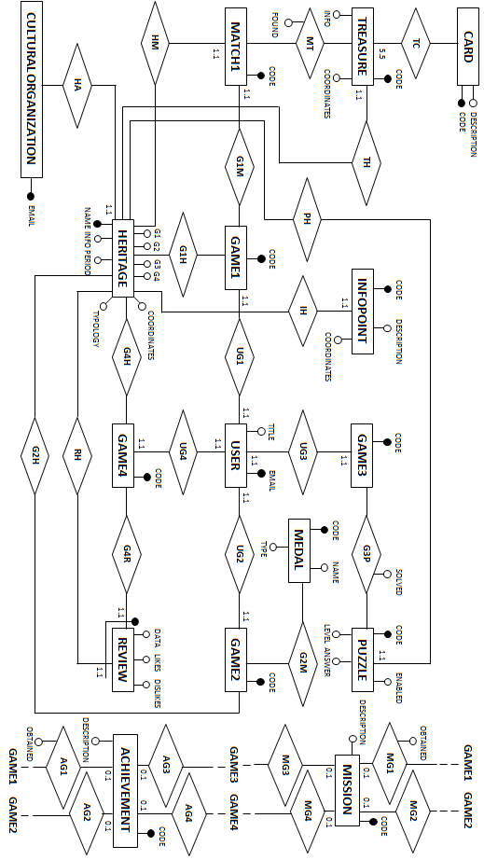

**Part 11: queries and Server call**

**Main menu - App side**

**1)** Loading of the main page showing the four portals with their bricks (representing progress in the game) on the basis of achievements (each "select" is relative to the "count" of each of the 4 games)

SELECT count (achievement)

FROM user, game1, achievement

WHERE user.email = 'own_email' AND user.game1 = game1.code AND mg1.game1 = game1.code AND mg1.achievement = achievement.code AND achievement.obtained = 'true" ;

SELECT count (achievement)

FROM user, game2, achievement

WHERE user.email = 'own_email' AND user.game2 = game2.code AND mg2.game2 = game2.code AND mg2.achievement = achievement.code AND achievement.obtained = 'true" ;

SELECT count (achievement)

FROM user, game3, achievement

WHERE user.email = 'own_email' AND user.game3 = game3.code AND mg3.game3 = game3.code AND mg3.achievement = achievement.code AND achievement.obtained = 'true" ;

SELECT COUNT (achievement)

FROM user, game4, achievement

WHERE user.email = 'own_email' AND user.game4 = game4.code AND mg4.game4 = game4.code AND mg4.achievement = achievement.code AND achievement.obtained = 'true" ;

**2)** Load the user title (chosen in those available according to the reached achievements)

SELECT title

FROM user

WHERE user.email = 'own_email';

**3)** Login to the game via email (the second parameter of "user" concerns the "title", while the next four will be occupied by the codes of the sessions of the respective four games when the user accesses it)

INSERT INTO user VALUES ('own_email', null, null, null, null, null);

**Main menu - Authoring Tool side**

**1)** Entering its credentials, the cultural organization can view its properties that it has added on the web page

SELECT heritage.name, heritage.info

FROM cutluralorganization AS co, ha, heritage

WHERE co.email = 'own_email' AND ha.co = co.email AND ha.heritage = heritage.name;

**2)** The cultural institution can add its own property, by entering the name, type, GPS coordinates and historical period in which the cultural heritage belongs

INSERT INTO heritage VALUES ('Colosseo','anfiteatro','168.32','Età Romana');

**3)** When the cultural organization puts the check on the category of a particular game to indicate that the property is part of the portal

UPDATE bene SET column5 = 'true'

WHERE name = 'name_of_the_heritage'

**Portal Treasure - App side**

**1)** Display the cultural heritage available to play

SELECT heritage.name

FROM heritage

WHERE heritage.g1 = 'true';

**2)** Clicking on the cultural heritage is created the match to play

INSERT INTO match VALUES ('code','colosseo','code_g1');

**3)** I take from the database treasures (and the data of those found) and the information of the place

SELECT treasure.code, treasure.info, treasure.found, treasure.coordinates

FROM treasure,th

WHERE th.heritage = 'own_heritage' AND th.treasure = treasure.code;

SELECT trasure.code

FROM treasure, mt, match1

WHERE match.code = 'own_match' AND mt.match1 = match1.code AND mt.treasure = treasure.code AND mt.found = 'true';

SELECT heritage.info

FROM heritage

WHERE heritage.g1 = 'true' AND heritage.name = 'name_of_heritage';

**4)** When I find a treasure chest

UPDATE mt SET found = 'true'

WHERE mt.match1 = 'own_match' AND mt.treasure = 'treasure_founded';

**Portal Treasure - Authoring Tool side**

**1)** Update (or add) the information on a property

UPDATE heritage SET info = 'info_file.txt'

WHERE name = 'name_of_heritage';

**2)** Add a chest of a specified cultural heritage (code, coordinates, description, code of the cultural heritage)

INSERT INTO treasure VALUES ('0005','234.65','description','0345');

INSERT INTO th VALUES ('0005','0345');

**3)** Request the list of the chests to be included in the map

SELECT treasure.code

FROM treasure

WHERE treasure.heritage = 'own_heritage';

**4)** Delete a chest

DELETE FROM treasure WHERE code = 'code_of_treasure_deleting'

DELET FROM th WHERE th.treasure = 'code_of_treasure_deleting';

**Portal Travel - App side**

**1)** I view cultural objects on the map (those who visited and those unvisited)

SELECT heritage.name, heritage.coordinates, g2h.visited

FROM heritage, g2h, game2

WHERE game2 = 'own_game';

**2)** When you visit a place, the corresponding dot on the map turns green

UPDATE g2h SET visited = 'true'

WHERE g2h.game = 'own_session' AND g2h.heritage = 'heritage_visited';

**3)** Displaying medals

SELECT medal.code, medal.name, medal.type, g2m.obtained

FROM g2m, medal

WHERE g2m.game2 = 'own_session'

**4)** I report to the database when I win a medal

UPDATE g2m SET obtained = 'true'

WHERE g2m.game2 = 'own_session' AND g2m.medal = 'code_medal_obtained';

**Portal Puzzle - App side**

**1)** View available events

SELECT puzzle.code, puzzle.level

FROM puzzle, game3, g3p

WHERE puzzle.enabled = 'true' AND g3p.game3 = 'own_session' AND g3p.puzzle = puzzle.code AND g3p.solved = 'false';

**2)** If you answer correctly, you will solve the riddle

UPDATE g3p.solved SET 'true'

FROM g3p, puzzle

WHERE g3p.game3 = 'own_session' AND g3p.game3 = 'current_puzzle' AND puzzle.answer = 'own_answer';

**Portal Puzzle - Authoring Tool side**

**1)** Selected a cultural property, I view its puzzles

SELECT puzzle.code, puzzle.answer, puzzle.level

FROM puzzle, ph, heritage

WHERE ph.heritage = 'name_of_heritage' AND ph.puzzle = puzzle.code

**2)** Add a new puzzle (code level, correct answer, boolean active)

INSERT INTO puzzle VALUES ('0921','0','correct_answer','true')

INSERTO INTO ph VALUES ('colosseo','0921');

**3)** Disabling a finished puzzle

UPDATE puzzle.enabled SET 'false'

WHERE puzzle.code = 'own_puzzle'

**Portal Knowledge - App side**

**1)** I choose the cultural property of which want the information

SELECT heritage.name

FROM heritage

WHERE heritage.g4 = 'true';

**2)** Viewing info points for the property where I am

SELECT infopoint.code, infopoint.coordinates, infopoint.description

FROM infopoint, ih

WHERE ih.heritage = 'own_heritage' AND ih.infopoint = infopoint.code;

**3)** Click on the infopoint I'm interested in

SELECT infopoint.description

FROM infopoint

WHERE infopoint.coordinates = 'own_coordinates';

**4)** I post a review (session game4, data, likes number, dislikes, cultural heritage that I review)

INSERT INTO review VALUES ('0343','Opera molto...',0,0,'Colosseo');

**5)** View all reviews of a specific property

SELECT review.data, review.likes, review.dislikes

FROM review, rh

WHERE rh.heritage = 'own_heritage' AND rh.review = review.game4;

**6)** Put like / dislike to a specific review

UPDATE review.likes SET 'likes+1'

WHERE review.game4 = 'usercode' AND review.heritage = 'name_of_heritage';

**Portal Knowledge - Authoring Tool side**

**1)** Add a new information point (code, coordinates, description, cultural heritage)

INSERT INTO infopoint VALUES ('0234','345.546','Il dipinto mostra...','San Pietro');

INSERT INTO ih VALUES ('0234','San Pietro');

**2)** Delete information point

DELETE INTO infopoint WHERE infopoint.code = '0234';

DELETE INTO ih WHERE ih.infopoint = '0234';

**3)** Enter a new description of the cultural property

UPDATE heritage SET info = 'text.txt'

WHERE heritage.nome = 'name_of_cultural_heritage';

**4)** Show user reviews

SELECT review.data, review.likes, review.dislikes, review.game4.user AS user

FROM review, game4, user

WHERE review.heritage = 'own_heritage';

**Administrator page - Authoring Tool side**

**1)** Adding new cards Game 1

INSERT INTO card VALUES ('0342','Carta Colosseo');

**2)** Adding new missions / achievements inherent to 4 games

INSERT INTO mission VALUES ('1033','Descrizione_missione');

INSERT INTO mg1 VALUES ('1033','0943');

**3)** Adding new medals

INSERT INTO medal VALUES ('9832','name_of_medal','type_of_medal')